REPUBLIC OF CAMEROON
Peace - work - Fatherland
MINISTRY OF HIGHER EDUCATION

REGIONAL DELEGATION OF CENTER

PKFokam Institute of Excellence

Dignity - Faith – Responsibility
P.O.BOX 11646 Yaoundé – Cameroon
RÉPUBLIQUE DU CAMEROUN
Paix - travail – Patrie
MINISTÈRE DE L’ENSEIGNEMENT SUPÉRIEUR

DÉLÉGATION REGIONALE DU CENTRE

PKFokam Institute of Excellence

Dignité - Foi – Responsabilité
P.O. Box 11646 Yaoundé – Cameroun

Project Progress Report
Restaurant Management Web Application

Framework | Django (Python 3.x)
Database | MySQL Restaurant DB
Architecture | MVT (Model-View-Template)
Modules | 7 functional modules
Team Size | 4 students
GitHub link | https://github.com/pettangroddysenpai-ship-it/Restaurant-Management-App

Group Members | Participation
Pettang Feumba Roddy Alann | 20%
Tiofack Kaze Franck | 20%
Matchim Dzuyim Verenne Celia | 20%
Mekolle Tuatsop Dalhia Aure | 20%
Messi Zang Paul Jacques | 20%

LECTURER: Mr. mbieteu amos mb.
DATE: Friday, 7th march 2026

Table of Contents
1. Introduction ................................................................................................ 1
2. Phase 1 project setup and configuration (Necessary tools for Django, SQL and Python Tasks) .................................................. 2
2.1 Download and Installation of Git, GitHub and Creation of Repository
2.2 Download and Installation of SQL and Django tools
2.3 Django Project Setup
Project Management ..................................................................................... 3
6.1 Gantt Chart
6.2 Class Diagram
2. Phase 2 Django Models (23 SQL Tables in Python) .................................................. 4
2.1 Orders App Models
2.2 Products App Models
2.3 Inventory, HR, Delivery & Finance Models
3. Phase 3 Authentication & User Roles ................................................................ 6
3.1 Custom User Model
3.2 First Migration & Superuser
3.3 Login / Logout Views
3.4 Role-Based Permission Decorators
4. Phase 4 Templates & Base Interface ................................................................ 8
4.1 Static Files & Template Folder Structure
4.2 Base Template (base.html)
4.3 Child Template Pattern
5. Phase 5 Views, URLs & Business Logic .............................................................. 10
5.1 Standard CRUD Pattern
5.2 URL Wiring
5.3 Low-Stock Alert Logic
5.4 Invoice Generation
7. Challenges & Solutions ................................................................................. 14
8. Conclusion ................................................................................................ 15

1. Introduction
As part of the Python Programming course delivered at the PKFIE Institute of Excellence, our group of four (4) students was tasked with designing and developing a comprehensive restaurant management web application. This application is built on the Django (Python) framework and uses a pre-designed MySQL database composed of 23 tables covering all the operational needs of a modern restaurant.
In order to efficiently organize our work and meet the project requirements, we divided the development of the application into three (3) distinct phases as follows:
Phase | Title | Description
Phase 1 | Setup & Configuration | Setting up the development environment, installing all required tools, creating the Django project, configuring MySQL and importing the existing database.
Phase 2 | Models & Application Foundation | Writing Django models corresponding to the 23 SQL tables, setting up the authentication system and user role management.
Phase 3 | Interfaces, Business Logic & Deployment | Building views, HTML templates, the dashboard, financial reports, implementing security measures and preparing all final deliverables.
This report documents the progress made during Phase 1, which forms the technical foundation of the entire application. Each step is presented with the commands used and a screenshot to support the work done.
This report documents the development of a Restaurant Management Web Application built using the Django framework (Python 3.x) and a MySQL relational database comprising 23 tables. The project was conceived to digitalize and centralize the core operations of a restaurant, including order management, inventory tracking, human resources, delivery coordination, and financial reporting.
The application follows the Model-View-Template (MVT) architectural pattern native to Django, ensuring a clean separation of concerns between data models, business logic, and presentation. Seven functional modules were implemented to cover the full operational scope of a modern restaurant.
This report focuses specifically on Phases 2 through 5 of the development lifecycle, covering the following key milestones:
- Phase 2 Defining all Django models that map to the 23 existing SQL tables.
- Phase 3 Implementing authentication, custom user roles, and role-based access control.
- Phase 4 Building the shared HTML template system and the base interface layout.
- Phase 5 Developing the views, URL routing, and core business logic for each module.
In addition, this report includes a Project Management section presenting the Gantt chart and class diagrams used to plan and design the system. A dedicated section on challenges encountered during development and the solutions applied is also provided, followed by a conclusion summarizing outcomes and lessons learned.
The development of a restaurant management system requires proper planning, analysis, and design in order to ensure efficiency and reliability. This project focuses on modeling and organizing the different activities involved in managing a restaurant through the use of software engineering tools.
Effective project management was essential to coordinate the development of seven modules across multiple phases. Two key planning and design tools were used: a Gantt chart to schedule and track progress, and class diagrams to model the system's data structure and relationships.

6.1 Gantt Chart
The Gantt chart below illustrates the planned timeline for the project across all development phases. Each phase is represented as a horizontal bar spanning its estimated duration, allowing the team to visualize task dependencies, parallelization opportunities, and overall project progress.
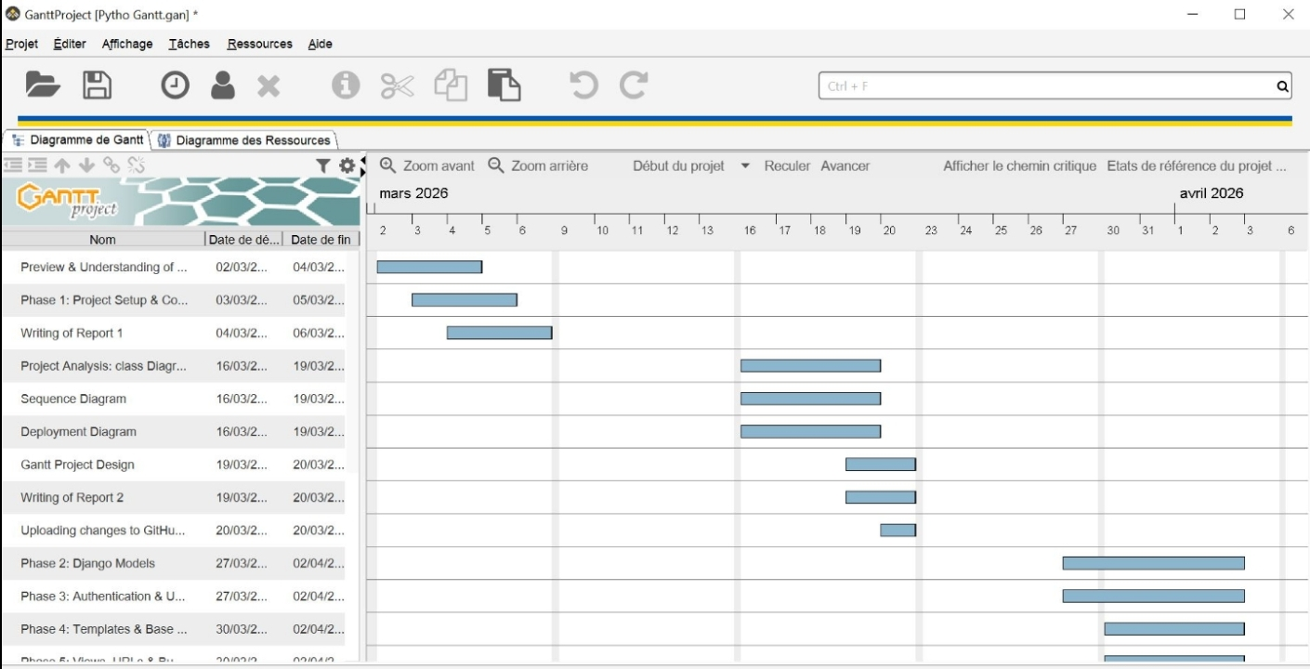

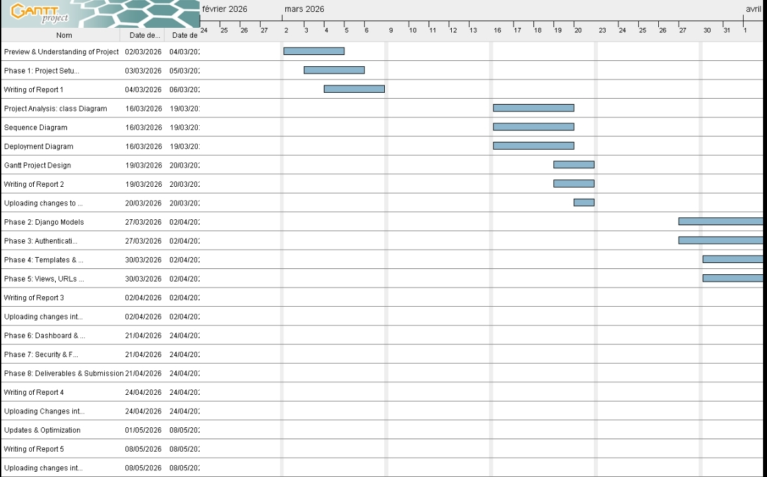

6.2 Class Diagram
The class diagram below represents the object-oriented structure of the Django application, showing all model classes, their attributes, data types, and the relationships between them (one-to-many, many-to-many, and foreign key associations).
Key relationships visible in the diagram include: Commande linked to Client and LigneCommande; LigneCommande linked to Produit; CompositionProduit linking Produit and Ingredient; Stock linked to Ingredient; and Affectation linking Employe and Poste.

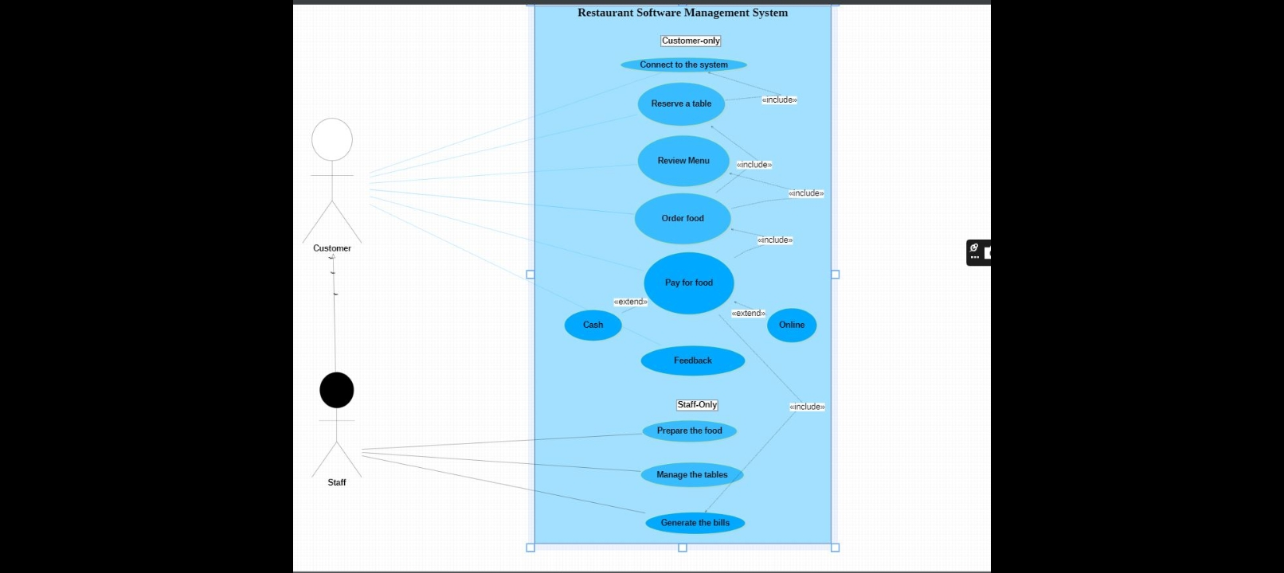

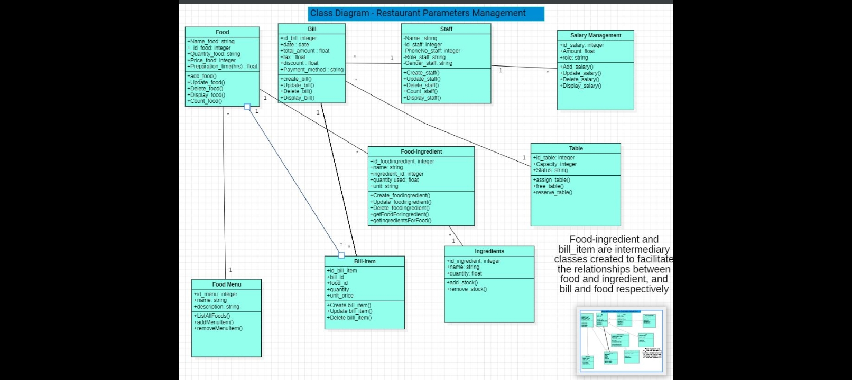
2. Phase 1: Project Setup & Configuration
The goal of Phase 1 is to prepare the entire Django project structure before writing any application code. This phase covers seven (7) essential steps that were carried out in the order listed below.
Step 1: Installing the Required Tools
The first action was to install all the Python libraries needed for Django to function and to connect to MySQL. These installations were carried out using the pip tool in the Windows Command Prompt.

The following packages were installed:
- Django; the main Django web framework
- MySQL client; the connector that allows Django to communicate with MySQL
- pillow ; image handling Library
- python-decouple; stores sensitive credentials (passwords) in a separate .env file away from GitHub
Step 2: Creating the Django Project
After installing the required tools, we created the base Django project structure. This was done from the terminal inside our group's working folder.

django-admin startproject restaurant_project
cd restaurant_project

These commands automatically generate the following file structure:

restaurant_project/
├── manage.py ← Django entry point
└── restaurant_project/
├── settings.py ← main configuration file
├── urls.py ← main URL router
└── wsgi.py
Step 3: Creating One Django App Per Module
In line with the functional requirements of the project, each restaurant management module was translated into an independent Django application. This modular organization respects the MVT (Model-View-Template) architecture required by the project specifications.
The following eight (8) applications were created using the commands below and each command creates a folder containing the following base files (example with the orders app):
Application | Module Covered | SQL Tables Used
users | User Management | CustomUser (new table)
products | Product & Recipe Mgmt | Produit, Ingredient, Composition_Produit
orders | Order Management | Commande, Ligne_Commande, Client, Table, Reservation
inventory | Inventory Management | Stock, Variation_Stock, Approvisionnement, Fournisseur
hr | HR Management | Employe, Poste, Affectation, Supervision
delivery | Delivery Management | Livraison, Deplacement, Vehicule
Finance | Finance Management | Facture, Equipement, Maintenance, Action_Marketing
dashboard | Dashboard & Reports | Aggregation of all tables

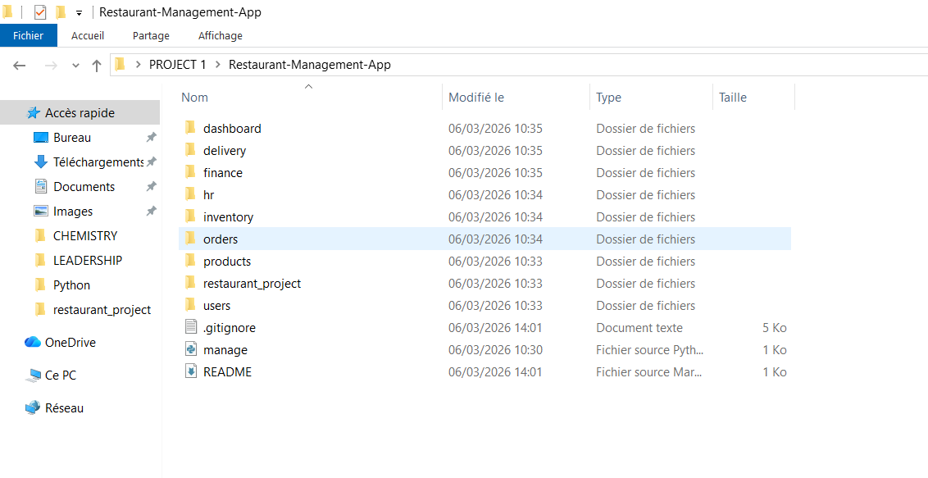
Step 4: Configuring MySQL in settings.py
We then configured the connection between Django and the MySQL database. To do this, the DATABASES block in the settings.py file was updated to point to the Restaurant database, using the standard port 3306 and the utf8mb4 encoding that matches the existing database.
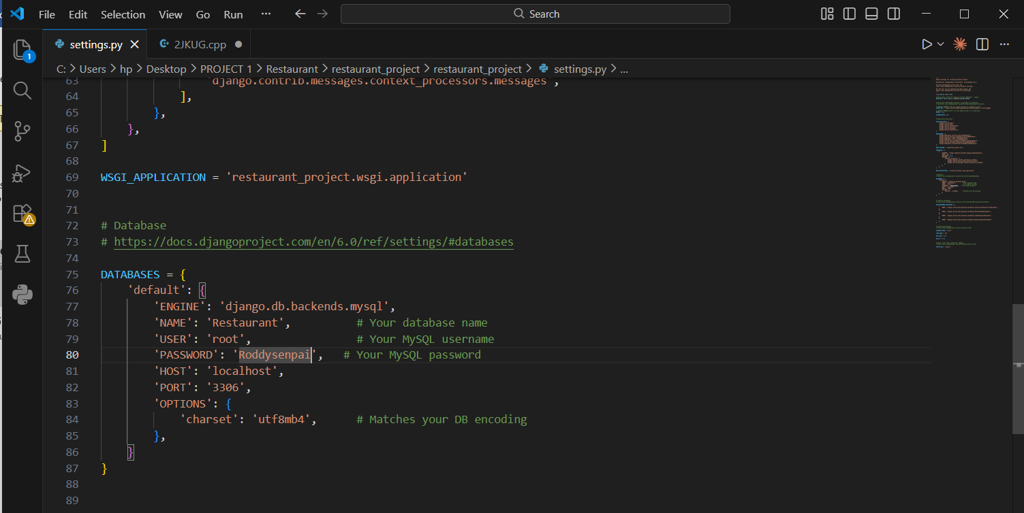
Step 5: Registering the Apps in settings.py
For Django to recognise the eight applications created in Step 3, each one was added to the INSTALLED_APPS list in settings.py. Without this step, Django would completely ignore those modules.
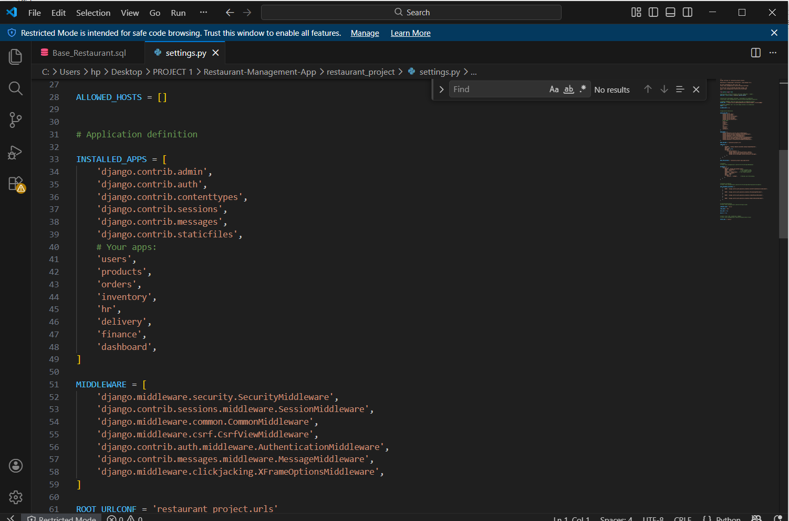

Step 6: Importing the MySQL Database
The database file provided for the project (Base_Restaurant__1_.sql) already contains all 23 tables as well as test data. This database was imported directly into MySQL via the Windows Command Prompt.

6.1 Installing MySQL
Before importing, it was necessary to install MySQL Server on our Windows machine. We downloaded the installer from the official website dev.mysql.com/downloads/installer, selected the Custom installation type to limit data usage, and configured the server with a root password.
After installation, the path to the MySQL executables was added to the Windows system environment variables (PATH) so that the mysql command could be used from any terminal:

C:\Program Files\MySQL\MySQL Server 8.0\bin
6.2 Importing the SQL File
Once MySQL was correctly installed and accessible from the terminal, we navigated to the folder containing the SQL file and ran the import command:

cd "C:\Users\hp\Desktop\PKFOKAM\FRESHMAN 1\Python"
mysql -u root -p < Base_Restaurant__1_.sql
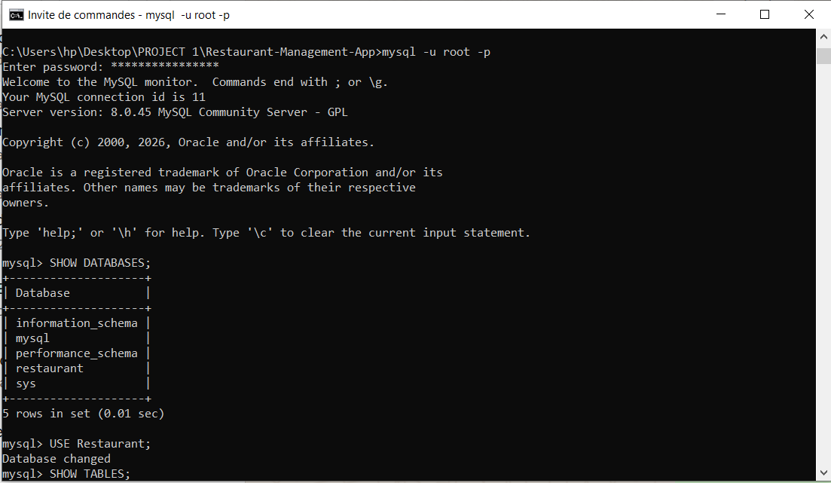
When prompted, we entered the MySQL root password. The absence of any error message confirmed that the import was successful.
6.3 Verifying the Import
After importing, we verified that the database and its 23 tables were correctly present in MySQL by running the following commands:

mysql -u root -p
SHOW DATABASES;
USE Restaurant;
SHOW TABLES;
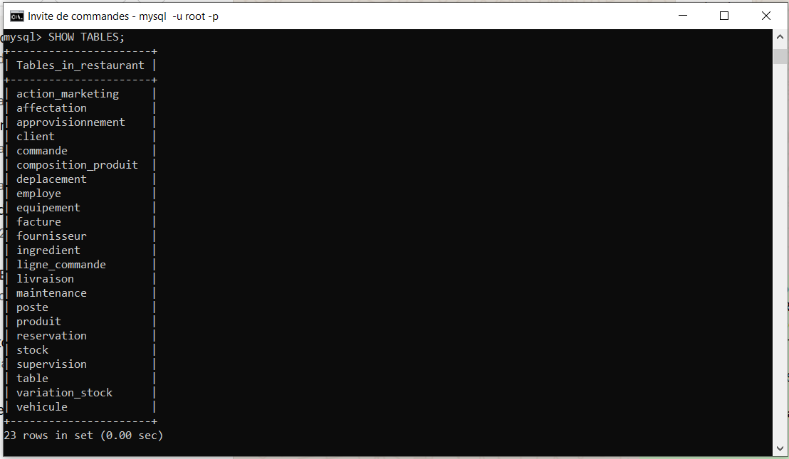
Step 7: Testing the Django–MySQL Connection
The final step of Phase 1 was to verify that Django communicates correctly with the MySQL database. This check is performed with the following command, run from the root folder of the project:

python manage.py check

# Expected result:
# System check identified no issues (0 silenced).

A result with zero errors confirms that the Phase 1 configuration is complete and that the project is ready for Phase 2, which involves writing the Django models for all 23 database tables.
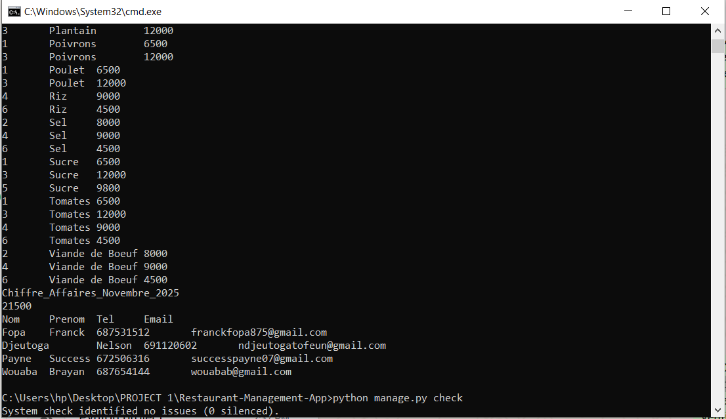

3. Setting Up the GitHub Repository
Alongside the Django project configuration, our group set up the GitHub repository for the project, in compliance with the project requirement that mandates the use of GitHub for source code management and collaborative development.
3.1 Creating GitHub Accounts
Each member of the group created a personal account on github.com. Usernames were chosen to be professional and easily identifiable by the lecturer, as the repository is set to Public.
3.2 Creating the Repository
The group leader created the public repository with the following settings:
Here is the github link to access our repository : https://github.com/pettangroddysenpai-ship-it/Restaurant-Management-App

Setting | Value Chosen
Repository Name | Restaurant-Management-App
Visibility | Public
README File | Added automatically
.gitignore | Python template selected
Repository Link | https://github.com/pettangroddysenpai-ship-it/Restaurant-Management-App

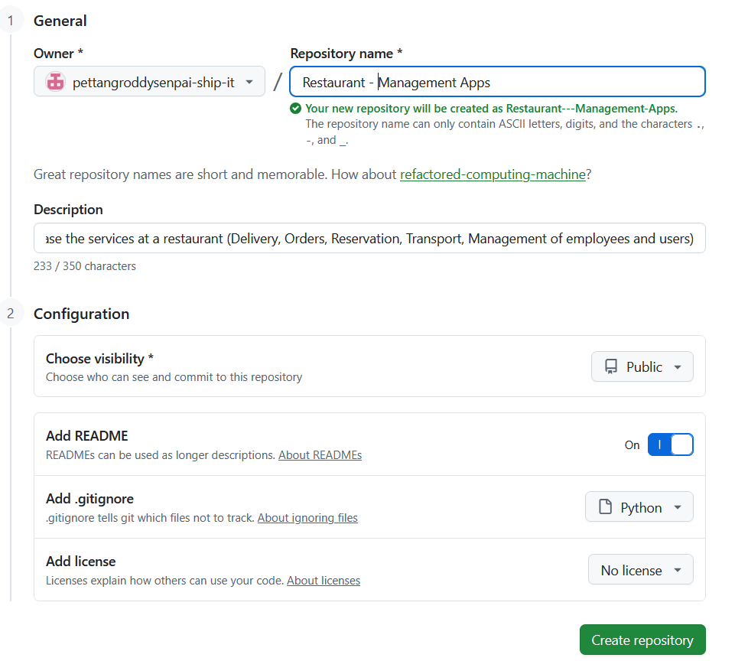
3.3 Adding Collaborators
The remaining group members were added as collaborators through the Settings → Collaborators page of the repository. Each member received an email invitation from GitHub which they accepted in order to gain push access to the repository.

# Navigate directly to the collaborators page:
https://github.com/pettangroddysenpai-ship-it/Restaurant-Management-App/settings/access

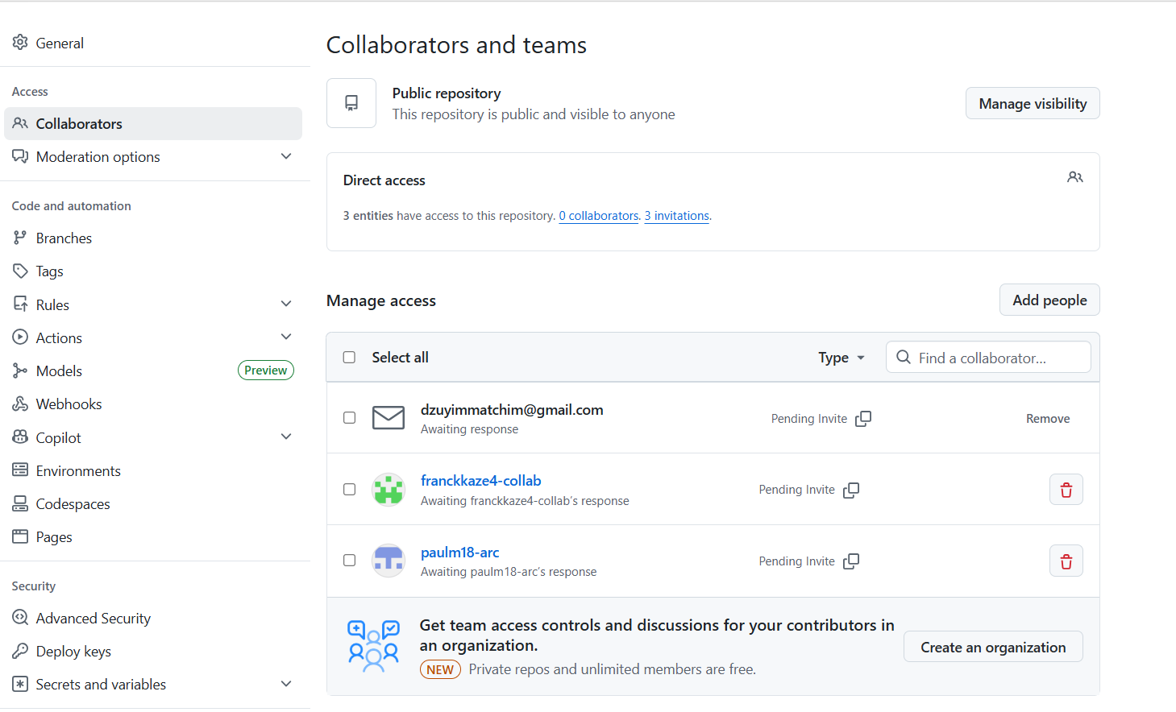
3.4 Cloning the Repository and First Push
After accepting their invitations, each group member cloned the repository onto their local machine. The group leader then performed the first push of the Django project structure to GitHub:

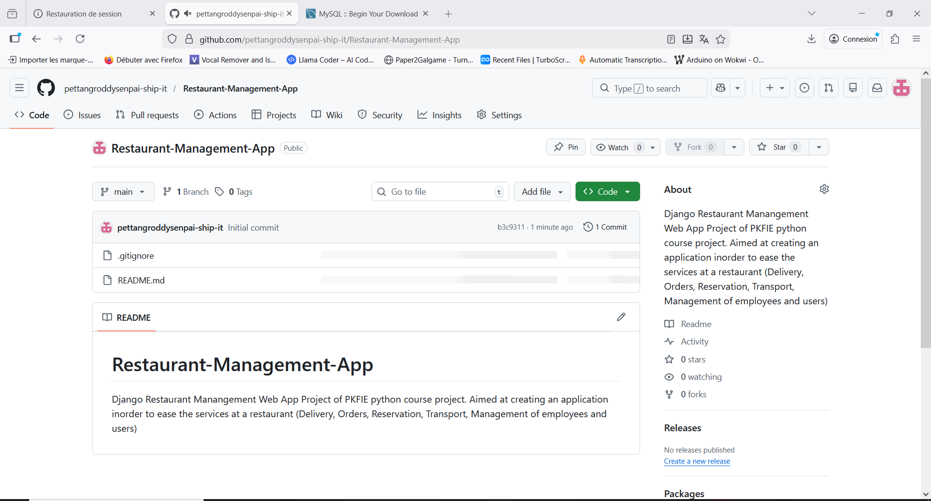
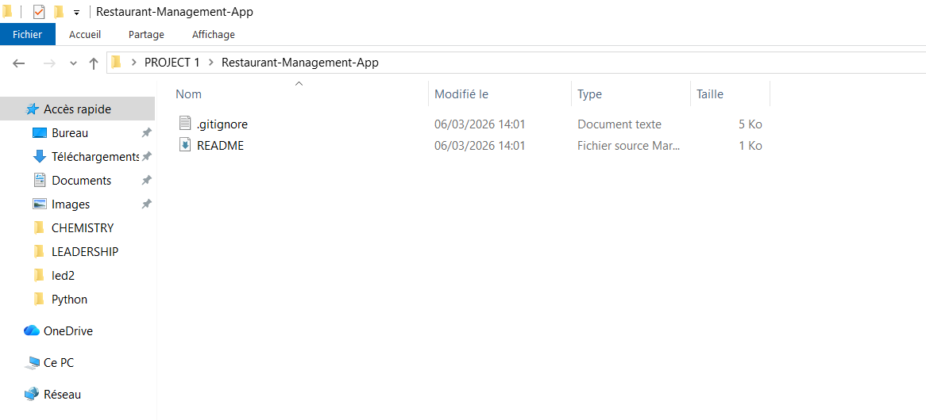
4. Phase 1 Summary
All steps of Phase 1 were completed successfully. The table below provides a full summary of the progress made during this phase:

# | Step | Status | Done By
1 | Install required Python packages (Django, mysqlclient, pillow, python-decouple) | ✅ Complete | Group
2 | Create the Django project with django-admin startproject | ✅ Complete | Group
3 | Create the 8 Django application modules | ✅ Complete | Group
4 | Configure MySQL connection in settings.py | ✅ Complete | Group
5 | Register all 8 apps in INSTALLED_APPS | ✅ Complete | Group
6 | Install MySQL, add to PATH, and import Base_Restaurant.sql | ✅ Complete | Group
7 | Test the Django–MySQL connection with manage.py check | ✅ Complete | Group
8 | Create GitHub repository and add all collaborators | ✅ Complete | Group

With Phase 1 fully complete, our group is now ready to begin Phase 2, which will involve writing the Django models for all 23 database tables and implementing the authentication system with role-based access control for the six user types defined in the project specifications.

2. Phase 2 : Django Models (23 SQL Tables in Python)

Phase 2 is the most foundational phase of the project. It involves translating all 23 existing MySQL tables into Python model classes within Django. Since the database tables were already created and populated via the Base_Restaurant.sql file, each model class was configured with managed = False, which instructs Django not to attempt to recreate or migrate these tables it simply maps to them.

2.1 Orders App Models
The orders app handles the core transactional data of the restaurant: clients, tables, reservations, orders, and order line items. The following models were defined in orders/models.py:
- Client Stores customer identity and contact details.
- TableRestaurant Maps to the SQL 'Table' entity (renamed to avoid conflict with Python's reserved word 'Table').
- Reservation Links a client to a table with date, time, and status.
- Commande Represents a full order with total amount and payment method.
- LigneCommande A junction table for order line items, linking orders to products with quantity and unit price.

2.2 Products App Models
The products app manages recipes, ingredients, and the composition of each dish. Three models were defined in products/models.py:
- Ingredient Represents a raw ingredient with its unit of measure and type.
- Produit A dish or product, linked to the employee who created it, with cooking time and serving count.
- CompositionProduit A junction table linking products to their ingredients with quantities used, implementing a composite primary key.

2.3 Inventory, HR, Delivery & Finance Models
The remaining four app modules each map to their respective SQL tables. The table below summarizes each app's models and key implementation notes:
App File | SQL Tables | Key Points
inventory/models.py | Stock, Variation_Stock, Approvisionnement, Fournisseur | Stock uses id_Ingredient as primary key (same as Ingredient PK)
hr/models.py | Employe, Poste, Affectation, Supervision | Affectation has a composite PK: (id_Employe, id_Poste)
delivery/models.py | Vehicule, Deplacement, Livraison | Deplacement has id_Chauffeur as FK to Employe
finance/models.py | Facture, Equipement, Maintenance, Action_Marketing | Facture.Type distinguishes client invoices from supply/salary/marketing records
For models with composite primary keys (such as Affectation), the unique_together Meta option was used to enforce uniqueness across the two foreign key fields, as Django does not natively support composite primary keys in the traditional sense.
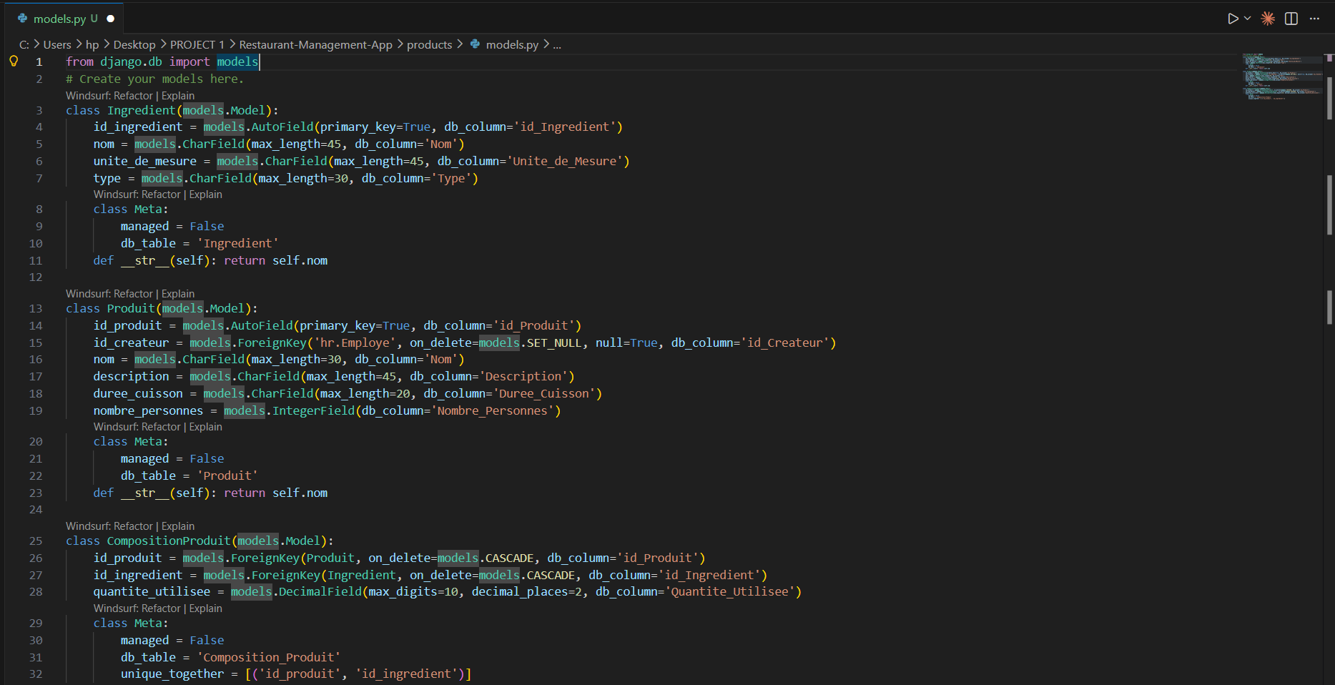
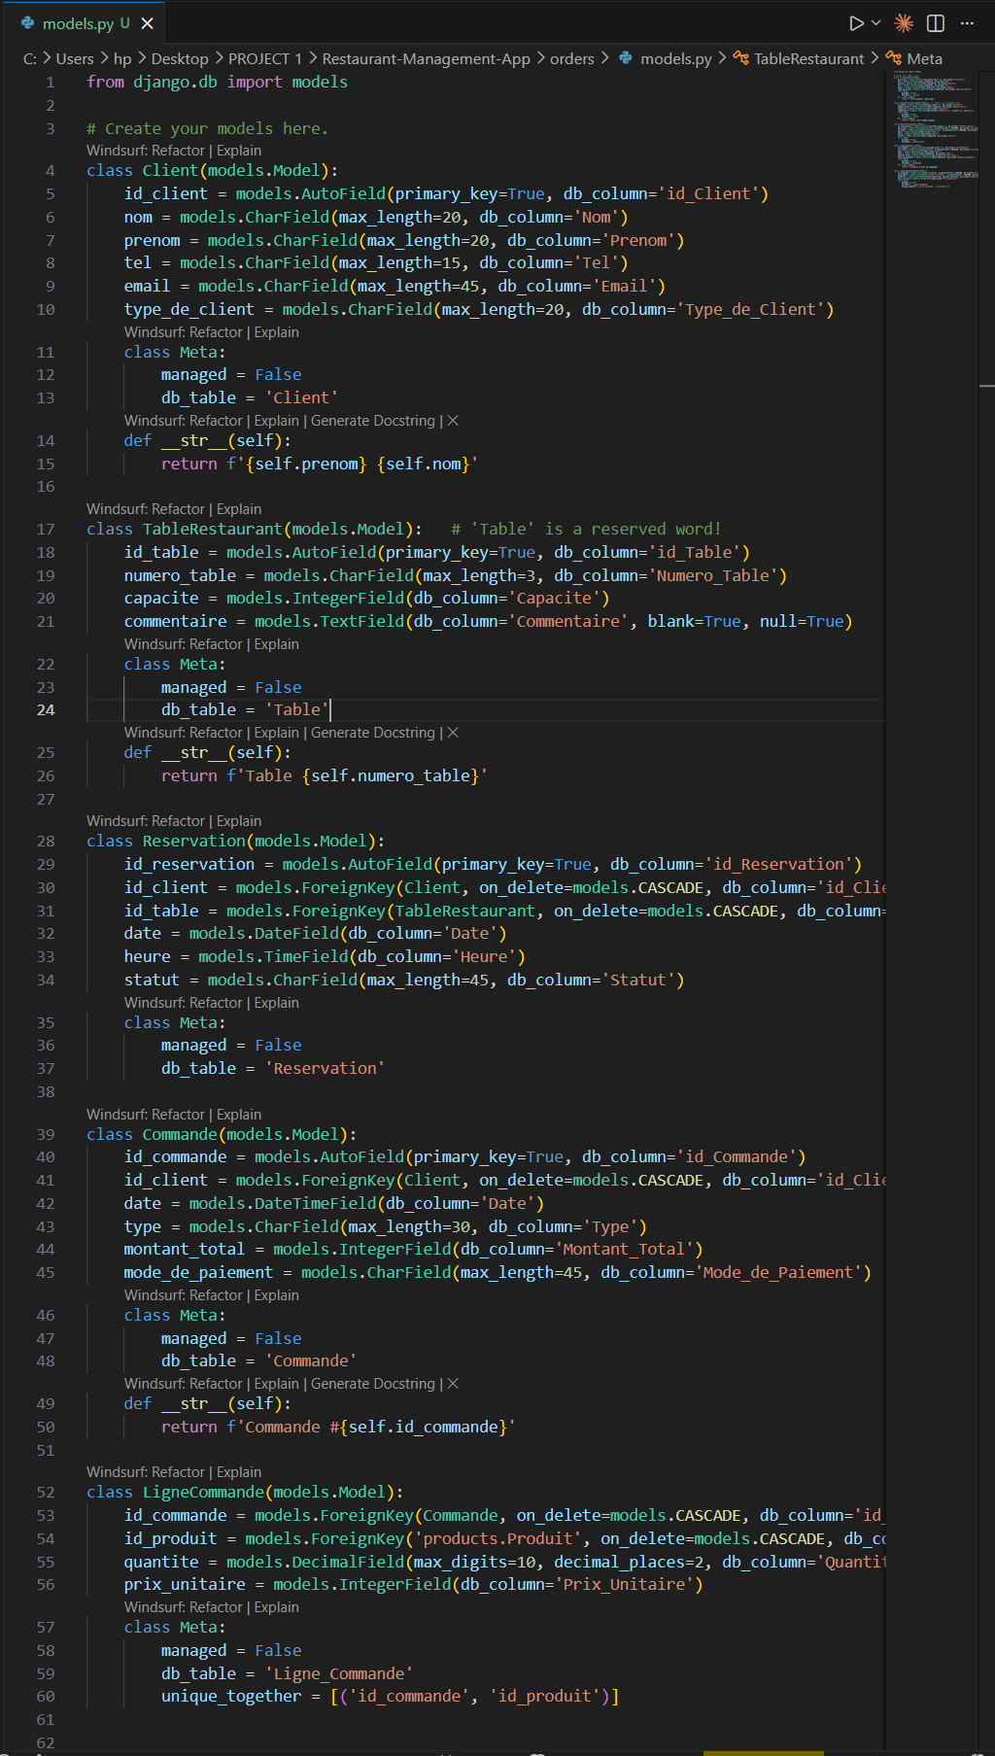3. Phase 3 : Authentication & User Roles

Django provides a built-in authentication system that was extended in this phase to support six distinct user roles corresponding to the restaurant's organizational structure. Rather than using Django's default User model, a custom user model (CustomUser) was created to add role-based access control.

3.1 Custom User Model
The CustomUser class extends Django's AbstractUser and introduces a role field with six predefined choices. It also includes an optional link to the Employe table via an integer field:
Role Key | Display Name
admin | Administrateur
director | Directeur
head_chef | Chef Cuisinier
cook | Cuisinier
server | Serveur
stock_manager | Gestionnaire de Stock
Django has a built-in authentication system. You will extend it to support the 6 roles defined in the project.

Step 11: Create the Custom User Model
In the users app, create a custom user that links to an Employe and has a role field:
# users/models.py
from django.contrib.auth.models import AbstractUser
from django.db import models

class CustomUser(AbstractUser):
ROLES = [
('admin', 'Administrateur'),
('director', 'Directeur'),
('head_chef', 'Chef Cuisinier'),
('cook', 'Cuisinier'),
('server', 'Serveur'),
('stock_manager', 'Gestionnaire de Stock'),
]
role = models.CharField(max_length=20, choices=ROLES, default='server')
# Optional: link to your Employe table
employe_id = models.IntegerField(null=True, blank=True)

def __str__(self):
return f'{self.username} ({self.get_role_display()})'

Then in settings.py, add this line so Django uses your custom user:
AUTH_USER_MODEL = 'users.CustomUser'

Step 12: Run the First Migration
This creates the users table (and Django's internal tables) in your MySQL database:

python manage.py makemigrations users
python manage.py migrate
python manage.py createsuperuser # Create your admin account

Step 13: Create Login and Logout Views
Django already has built-in login/logout views. In users/urls.py:
# users/urls.py
from django.contrib.auth import views as auth_views
from django.urls import path

urlpatterns = [
path('login/', auth_views.LoginView.as_view(template_name='users/login.html'), name='login'),
path('logout/', auth_views.LogoutView.as_view(), name='logout'),
]

Step 14: Create Role-Based Permission Decorators
Create a file users/decorators.py that you will use to protect any view by role:
# users/decorators.py
from django.contrib.auth.decorators import login_required
from django.core.exceptions import PermissionDenied
from functools import wraps

def role_required(*roles):
def decorator(view_func):
@wraps(view_func)
@login_required
def _wrapped_view(request, *args, **kwargs):
if request.user.role in roles:
return view_func(request, *args, **kwargs)
raise PermissionDenied
return _wrapped_view
return decorator

# Usage in any view:
# @role_required('admin', 'director')
# def delete_employee(request, pk): ...

4. Phase 4 Templates & Base Interface
Before building any module-specific pages, Phase 4 establishes the shared HTML layout infrastructure that all pages will inherit. This follows Django's template inheritance pattern, where a single base template defines the overall page structure, and child templates override specific content blocks.

4.1 Static Files & Template Folder Structure
Two key configuration settings were added to settings.py: TEMPLATES (to specify the global templates directory) and STATICFILES_DIRS (to locate CSS and JavaScript assets). The following folder structure was created manually at the project root:
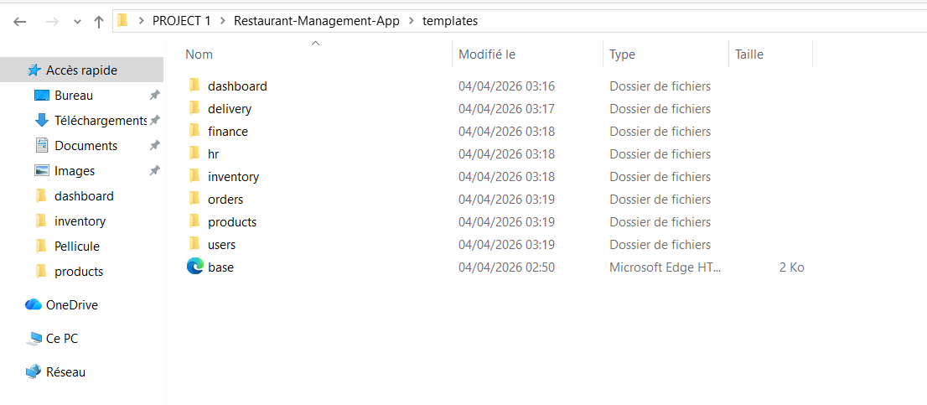
Each app has its own subdirectory inside templates/, separating HTML files by module. The static/ directory holds shared CSS and JS files accessible from any template using Django's {% static %} template tag.

4.2 Base Template (base.html)
The base.html file is the master layout for the entire application. It was built using Bootstrap 5, loaded directly from CDN to avoid any local installation. The template defines the following structural blocks :
- Navigation bar Displays the app name and links to major modules (Dashboard, Commandes, Stock, RH). The logout button is positioned at the right end.
- Flash messages block Automatically renders Django's message framework alerts (success, error, warning) between the navbar and the main content area.
- Content block An empty {% block content %} that each child template overrides with its specific page content.
- Extra JavaScript block An empty {% block extra_js %} placed at the bottom, allowing child templates to add page-specific scripts without polluting the global head.
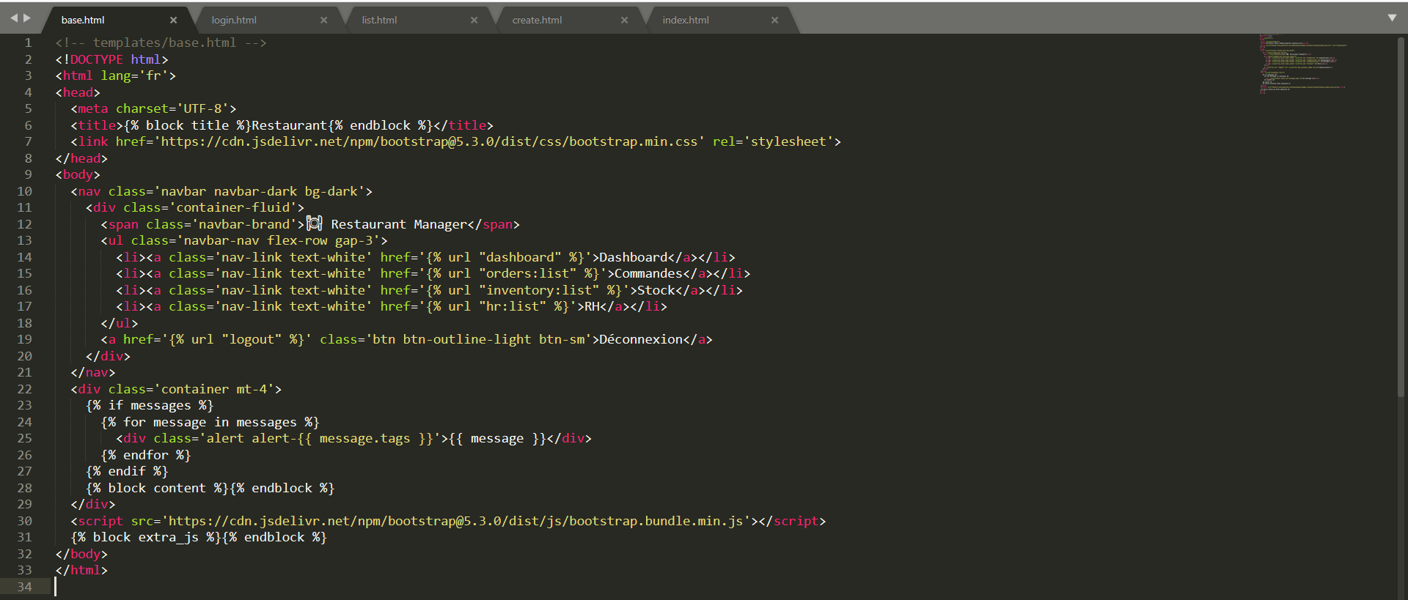

4.3 Child Template Pattern
Every other HTML page in the application starts with {% extends 'base.html' %} and overrides the {% block content %} and optionally {% block title %}. This ensures visual consistency across all pages while keeping each template focused only on its specific content.
As a demonstration, the orders/list.html template extends base.html and renders a Bootstrap-styled table of all orders, with columns for ID, client, date, total amount, and an action button linking to the order detail view.
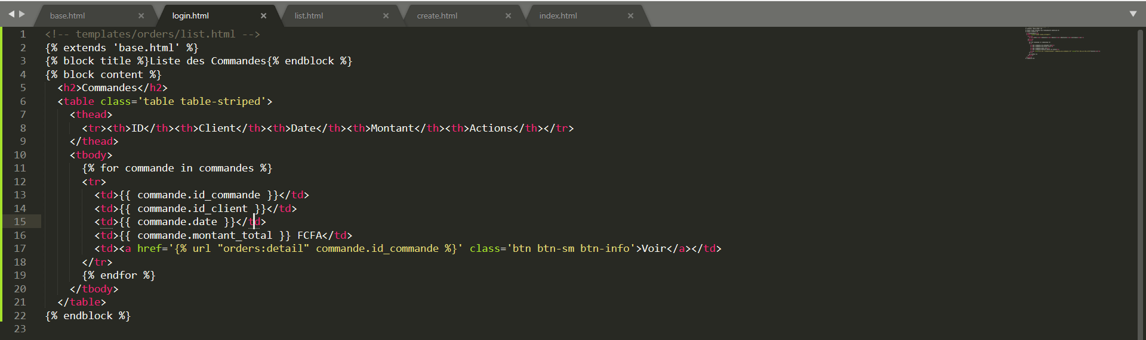

5. Phase 5 Views, URLs & Business Logic
Phase 5 is where the application becomes fully functional. Each module receives its views (the Python functions that process HTTP requests), URL patterns (the routes that map URLs to views), and business logic (the rules that govern data processing). Every module follows the same structural pattern: list, detail, create, edit, and delete.

5.1 Standard CRUD Pattern Orders Module
The Orders module serves as the reference implementation for the CRUD pattern applied across all modules. It involves four key views and an auxiliary helper function:
- order_list Retrieves all orders sorted by date (most recent first) and renders them in the list template.
- order_detail Retrieves a single order by primary key and its associated line items, then renders the detail view.
- order_create Handles both GET (display the creation form) and POST (process form submission). On POST, it creates the Commande record, iterates over submitted line items to create LigneCommande records, calculates the total amount, and triggers automatic stock deduction.
- deduct_stock_for_product A helper function called inside order_create that retrieves the product's ingredient composition and reduces each ingredient's stock quantity accordingly. It also logs a 'sortie' entry in the VariationStock table for traceability.

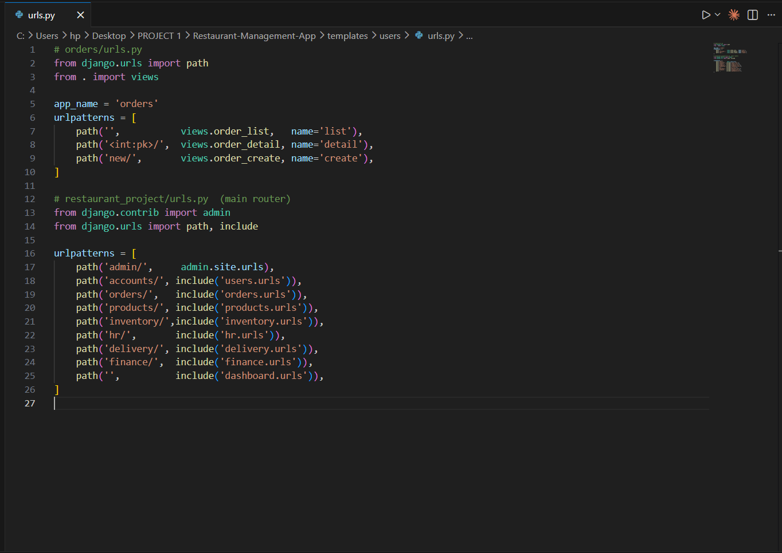
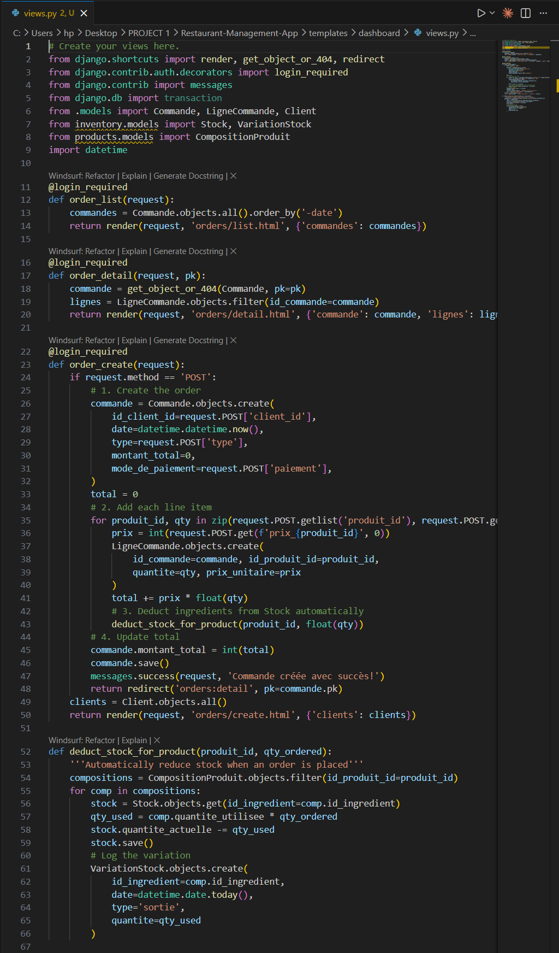

5.2 URL Wiring
Each app defines its own urls.py file with an app_name namespace to avoid URL name conflicts across modules. These app-level URL files are then included in the main restaurant_project/urls.py file using Django's include() function.
The main URL configuration registers the following route prefixes:
URL Prefix | App Included | Purpose
admin/ | django.contrib.admin | Django Admin Panel
accounts/ | users.urls | Login / Logout
orders/ | orders.urls | Order Management
products/ | products.urls | Product & Recipe Management
inventory/ | inventory.urls | Stock & Inventory
hr/ | hr.urls | Human Resources
delivery/ | delivery.urls | Delivery Tracking
finance/ | finance.urls | Finance & Invoices
/ (root) | dashboard.urls | Dashboard Home Page

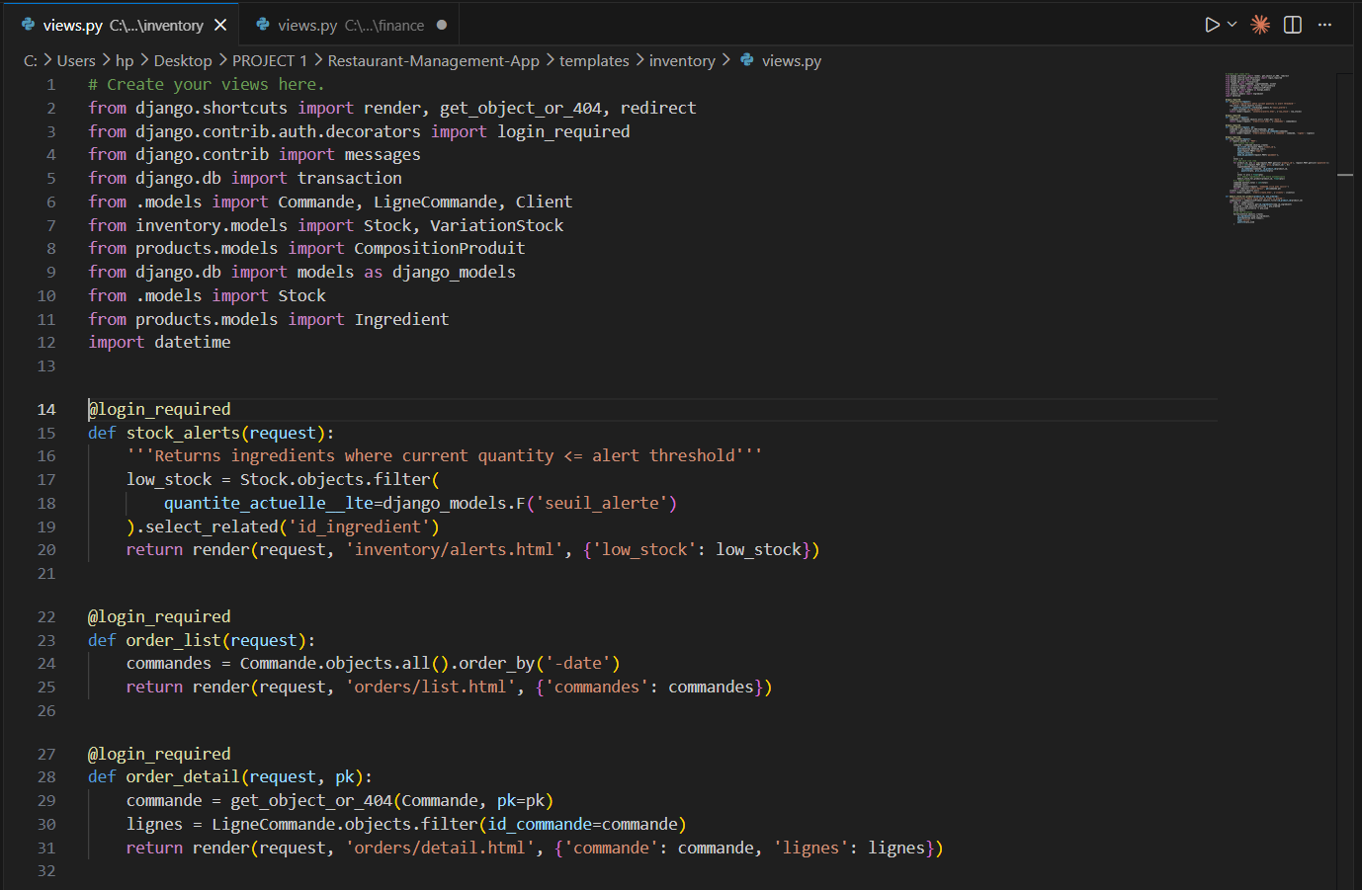

5.3 Low-Stock Alert Logic (Inventory Module)
A dedicated view was created in inventory/views.py to detect ingredients whose current quantity is at or below their defined alert threshold. This uses Django's ORM F() expression to compare two fields within the same model row, avoiding the need for raw SQL.
The query filters Stock objects where quantite_actuelle is less than or equal to seuil_alerte. The select_related() call ensures the related Ingredient data is fetched in the same database query (JOIN), avoiding N+1 query issues.
This view powers the stock alert widget displayed on the dashboard, providing real-time visibility into critical inventory levels.

5.4 Invoice Generation (Finance Module)
A printable invoice view was implemented in finance/views.py. This view retrieves a Commande object by its primary key and its associated LigneCommande records, then passes them to a dedicated invoice template. The template includes a 'Print' button that triggers the browser's native print dialog via a JavaScript onclick event.
This approach avoids any external PDF library dependency while providing a functional and printable invoice output that can also be saved as PDF from the browser's print dialog.

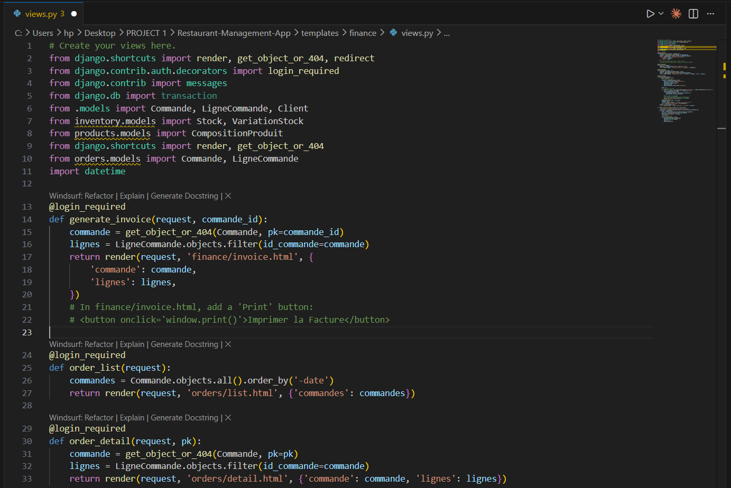
7. Challenges Encountered & Solutions
Several technical and organizational challenges arose during the development of this project. The following describes the most significant ones and the approaches used to resolve them.

Challenge 1: Composite Primary Keys in Django
Django does not natively support composite primary keys. However, several of the existing SQL tables (such as Affectation, LigneCommande, and CompositionProduit) used composite primary keys made of two foreign key columns.
Solution: The unique_together Meta option was applied in each affected model to enforce the uniqueness constraint at the Django ORM level. This approach successfully mirrors the composite PK behavior of the SQL tables without modifying the database schema.

Challenge 2: Reserved Word Conflict ('Table')
One of the SQL tables is named 'Table', which is a reserved keyword in Python and in Django's ORM. Naming a model class 'Table' caused syntax conflicts and unexpected behavior.
Solution: The model class was renamed to TableRestaurant in Python, while the db_table Meta attribute was set to 'Table' to maintain the correct mapping to the existing SQL table. This resolved the conflict without altering the database.

Challenge 3: AUTH_USER_MODEL Applied After Initial Migration
During early testing, the custom user model setting (AUTH_USER_MODEL = 'users.CustomUser') was added to settings.py after initial migrations had already been run. This caused migration dependency errors and broken foreign key references throughout Django's internal tables.
Solution: The database was reset entirely by dropping and recreating the Django-managed tables, and all migrations were re-run from scratch. This highlighted the critical importance of defining the custom user model before any migration is executed a step now documented as a warning in the development guide.

8. Conclusion
Phase 2 established a solid data foundation by mapping all SQL tables to Django model classes, respecting the existing schema through the managed = False configuration. Phase 3 introduced a secure, role-based access control system that differentiates between six types of users, ensuring that each staff member can only access the features relevant to their role. Phase 4 delivered a coherent and reusable user interface built on Django's template inheritance system, providing a consistent experience across all modules. Phase 5 brought the application to life with CRUD views, URL routing, and key business logic including automatic stock deduction and invoice generation.
From a project management perspective, the Gantt chart enabled clear scheduling and prioritization of tasks, while the class diagrams provided a shared visual reference for the system's data architecture. These tools were invaluable in coordinating development across multiple modules.

